GAM6001-18 Major Project

Individual Report

Assessment 02

McDonald, Bradley

1608793

Contents

Abstract 3

1.Background 3

1.1 Aims of the project. 3

1.2 The Team Composition 4

1.3 The Authors Role In The Team 4

1.4 The state of production from the start of second term. 5

2.Introduction 5

3.Technical Art 6

3.1 A Designer Creating Technical Art tools 9

3.1.1 Technical Art In Industry 11

3.1.2 How The Technical Art Work Was Approached 11

3.1.3 Problems, solutions and evaluation of this work in comparison to research undertaken 12

3.2 Testing method 13

4. Potential political views on the project 15

4.1 Australian Culture 15

4.2 Fantasy Animal Violence 16

4.3 Capitalistic propaganda 17

4.4 Censorship 18

5. Reflection 18

5.1 Individual Reflection (Evaluation) 18

5.2 Team Reflection 20

5.3Team Contribution 20

6. Conclusion 21

Appendix A – Testing Documents 24

Appendix B- Literature Review 57

7. Bibliography 69

Figure Table

Figure 1- Old Main Level CAD 5

Figure 2- New Main Level CAD 5

Figure 4- GPU Profiler ‘After Optimisation’ 8

Figure 3- GPU Profiler ‘Before Optimisation’ 8

Figure 5- Floating Platform Tool 10

Figure 6-Fence Tool 10

Figure 7-Volition's flowchart for feature requests as well as a change to management plan 12

Figure 8- Kuthbert Aiming Boomerang 16

Figure 9- Kuthbert With Enemy 16

Figure 10- Trapped Quoka 17

Figure 11- In front of World Portal 17

# Abstract

This report covers the intricate details of the development of the project Koala Rama from one of the designers. The topics covered are to be backed up with relevant literature and reliable sources. The topics mentions were a key part of development may that be in the start, middle or end. Topics such as technical art, testing and an intricate detailed look of how the project could be perceived after if it was released.

# 1.Background

The Team, for this module, created a 3D platforming game. The game was based on a bi-pedal Koala, who has to rescue his friends throughout a variety of worlds by utilising a variety of mechanics. The title of this game was Koala Rama.

## 1.1 Aims of the project.

The team wanted to create an aspiring 3D platformer with added unique gameplay mechanics whilst also including generic 3D platformer mechanics (such as Walking, Running, Jumping and double Jumping) as to still seem familiar to people who have played 3D platformers before. The team decided to add the unique elements as to set it aside from other previously released games in the same genre. Games of the same genre consist of Mario Odyssey (Nintendo,2017) and Spyro Reignited Trilogy (Activision, 2018), though these are developed by different companies they fall within the same genre, a 3D platformer. A 3D platformer as described by (Minkkinen, 2016) “’Platformers’ or ‘platform games’ are games that mainly revolve around a character controlled by the player, which runs and jumps to avoid obstacles and/or to defeat enemies”. This was the main gameplay element of the project, Koala Rama to explore multiple world whilst jumping to multiple platforms floating or not, avoiding hazards along the way in the form of obstacles or enemies.

## 1.2 The Team Composition

The team was made up of five third year undergraduate games students from various disciplines, an artist, a programmer and three designers. Each person applied skills that adhered to their role. Whilst branching into artist or programmer depending on workload. The artist created 3D models, unwrap, textured and imported into engine for the designers to place within the game. The Programmer focused primarily on Enemy AI and fixed bugs when attempting to build the game. The Designers would create tools for level design and polish to the game in the form of particle effects or sound, whilst creating and designing multiple levels for the player to navigate in Unreal Engine 4 (UE4), (Epic Games,1998).

## 1.3 The Authors Role In The Team

The Author carried out his role in the team as a designer in a small independent game development (indie) team would. To quote Mike Bithell, an indie game designer, writer (Freeman, 2015) of the guardian newspaper interviewed Mike Bithell who went onto say when asked the question: How varied is your role? Mike Bithell replied ‘*But then I still design game mechanics, I still do lots of coding, I still write the scripts, and do lots of things. It really doesn’t come under a single banner, so I use designer, because nobody really knows what that is anyway’*.

Which implies to use and learn a wide range of skills within the project, this is different than being a designer on a large AAA team, where the role would have been more specific, interviews with industry developers such as (Ismail, 2018) game director of Assassins Creed games, say how they have specific team members for specific jobs where it be seeing if ancient hieroglyphics are correct or researching locations. The role of being a generic designer meant going into different aspects of game development, such as; Gameplay Programming, Animating, UI Design, Technical Art and VFX. This allows for constant learning and developing new skills as the project progressed. Learning and developing is a key part to a designer as it allows them to prototype ideas before fully implementing them in game. This was done with a majority of the projects’ key mechanics as a proof of concept for the team. In the interview with (Ismail, 2018) tells how he prototyped the boat mechanics of which is featured in newer Assassins Creed titles. This prototype though took several months to complete and build upon whilst being a small team with strict resources the team was not able to complete this level of prototyping.

## •1.4 The state of production from the start of second term.

The prototype was at as stage where the core mechanics were working, such as; walking, jumping, rolling and throwing the boomerang. With these mechanics there were a small number of visual glitches to do with animations, of which needed polishing. The game itself was playable with one main level. However, with the overall design of the level done and with the better tools developed for level design, it became easier and more apparent to make more levels. The team then began planning on creating more levels and refining the ones already made.

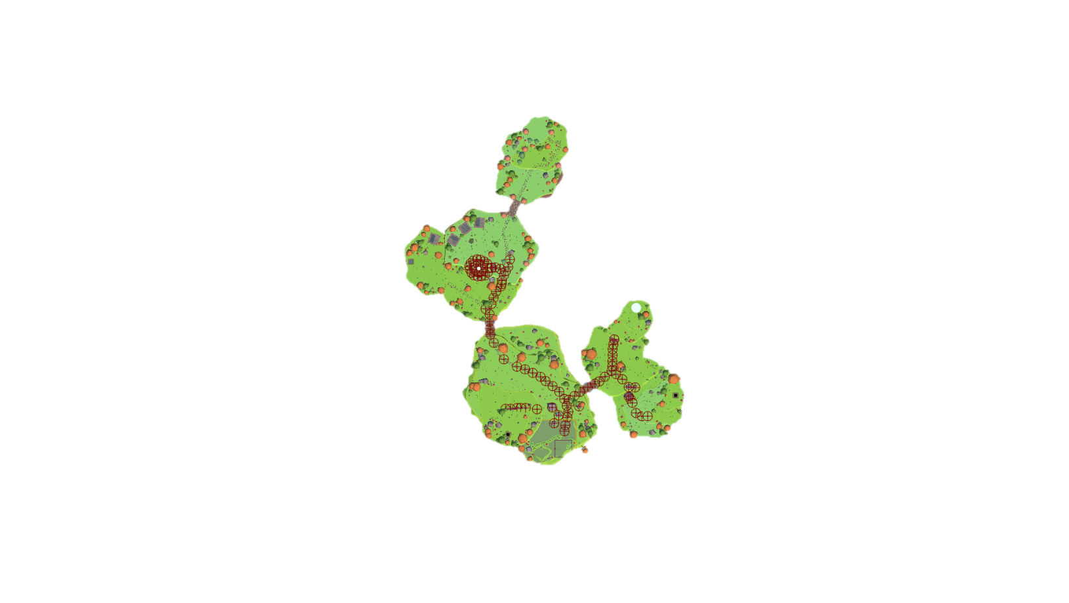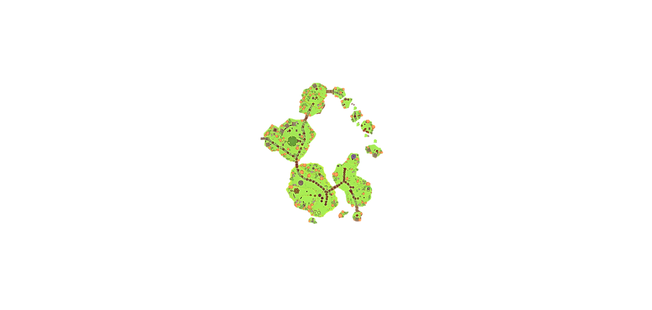

Figure 1- Old Main Level CAD

Figure 2- New Main Level CAD

## 2.Introduction

As one of the Designers of the team, many roles had to be undertaken to provide a quality product. The document will go into detail of these roles, what they were, how they were done and what effect these implementations had on development. These effects can range from implementing feedback from testing results, to setbacks in development which led to rework of the original design. This document will also go into detail of relevant literature and research of which informed the approach in this project, and if these findings actually were reflected in the project or not. The document will go into detail of the work the author has done on the project, the testing of the project and the potential political implications of the project. This will be followed by a reflection and conclusion of the authors work through the project, Koala Rama.

The author will relate back to previous submitted work at relevant parts to show how the project developed based upon certain aspects of the submitted work and project. This will primarily be focused upon when discussing testing and implementation of design into the developed project, including the potential political aspects of the project.

# 3.Technical Art

This section will cover the role of a technical artist and how the author took up this role through development to provide a greater service to the team and project.

The job of a technical artist as defined by (Full Sail University, 2018)

“*Something of a hybrid between an artist and a programmer is the video game technical artist. This person works under the direction of the art director and technical art director, and is responsible for the systems and tools associated with creating and porting art assets*”.

Though that is a definition of a technical artist, it is not the clearest. As an article by (Sokanu, 2019) states that

“*The role of technical artist is a relatively new one, but it is becoming increasingly important as consoles and PC hardware become more complicated. A technical artist works closely with the lead artist and the creative director, as well as the lead programmers. Their responsibilities include setting up and maintaining the workflow of art production, deciding which art packages and tools a studio should use, investigating new techniques, and then going ahead and implementing them*”.

Both quotes interlink with saying that the technical artist works alongside programmers and artists however verge when discussing tools, (Full Sail University, 2018) makes it seem that the technical artist simply decides on the tools that are being implemented whereas (Sokanu, 2019) goes into that the technical artist actually creates the tools needed for production. A technical artist at Ubisoft Bucharest (Ubisoft, 2016) goes onto say that “*In the beginning we’re focused on creating the pipeline, workflow and the tools the artists can work with*”. This keeps with how the author approached the role, creating various tools for the designers and artists whilst maintaining a stable version of the game through optimisation.

To take up the role of a technical artist, as based upon by the above, is to utilise both art and programming to create a multitude of tools so that Designers can speedily design, create and test level layouts and adjust them easily based on feedback. Be that feedback internal or external. That was one aspect of the role. As the author’s role of being a designer, with experience in both art and programming. The job was possible. With existing knowledge of game design, allowed the author to tailor the tools so that a fellow designer would be able to fully utilise the tool with little or no tutorial. As they knew themselves of what a tool needed and how it needed to function in the editor. As designers have an advantage of knowledge in other disciplines, as described by (Schell, 2008) in the Chapter ‘What Skills Does a Game Designer Need?’ she foes onto describe “ *In Short, all of them. Almost anything that can be good at can become a useful skill for a game designer*”. She then goes to list a number of skills from Anthropology to Visual arts. As the team was mostly designers and were all disciplined in these wide variety of skills, communication was simple through development of tools and of the project overall.

Another task that comes with the role of a technical artist it to optimise the game, by viewing the in-engine profiler, to see if any imported assets, created by the artist, effect the game. Either by performance (Frames per second) or if they create visual glitches (missing polygons or wrong facing normals). This can lead to unanticipated stops in production of which then need to be solved before any new alteration or iterations are added to the game.

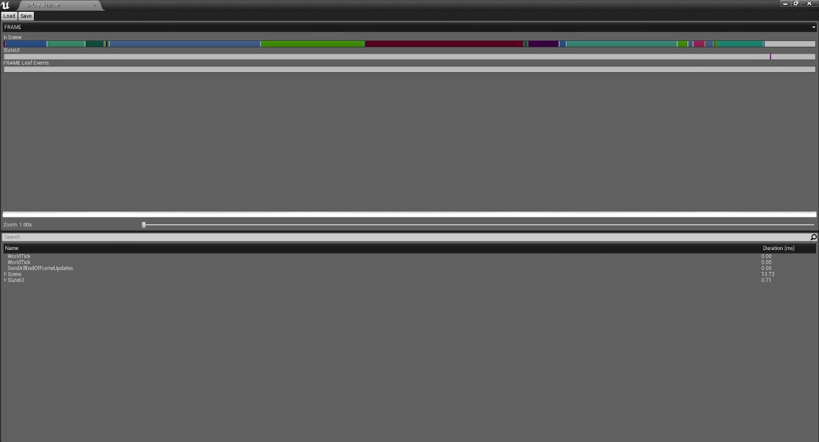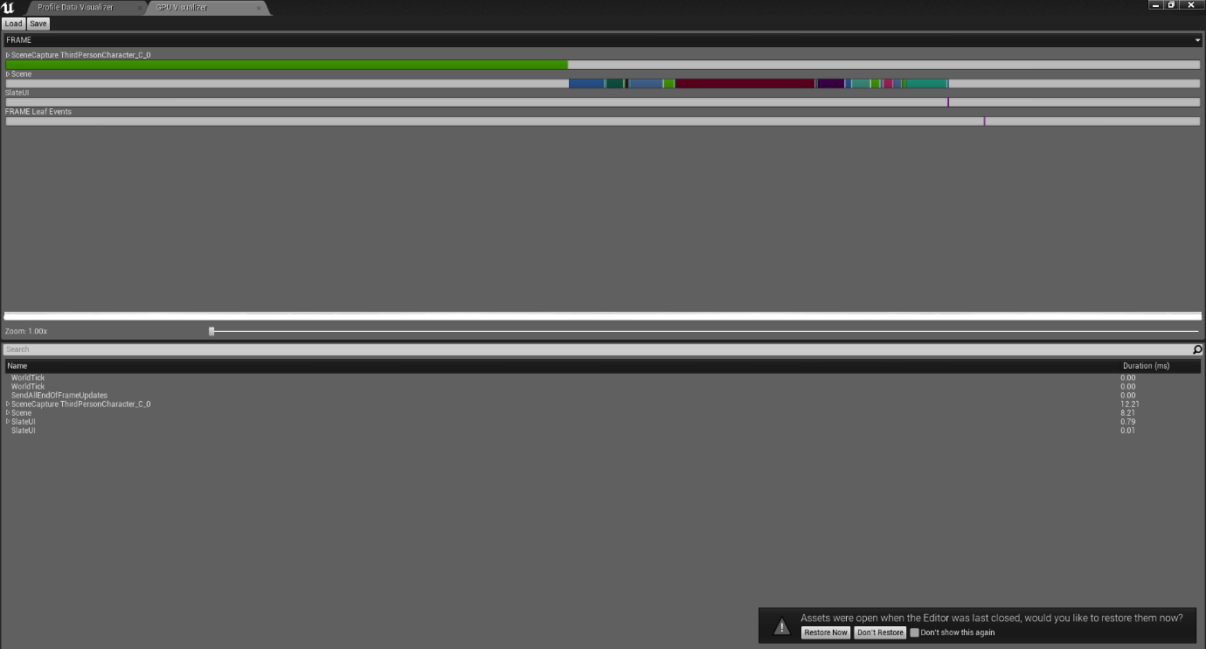

Figure 4- GPU Profiler ‘After Optimisation’

Figure 3- GPU Profiler ‘Before Optimisation’

The green bar seen in figure 3 above, shows the memory usage for the Third Person character. This visualisation aids in debugging which assets need correcting. In this instance it was the Third Person Character Blueprint that was taking the majority of the memory. So, to optimise the game the author researched a variety of methods to optimise the game. Originally in the design of the game the player was to gradually gain their abilities such as double jump and roll, with this in mind the author researched ‘Composition over inheritance’ (Johansson, 2015) whom details to ‘define objects of what they can do rather than what they are’. So that later I could define the playable character as an object that could ‘fight’ or ‘roll’ rather than constantly checking if they could due do those things by what it is. This method was ideal however later in production the team decided it was better to ensure the player has all the abilities from the start of the game. This decision was made due to internal testing and also development time constraints, the team could not get the ‘unlock ability’ system working whilst also implementing other assets into the game. As the system was never in place, the level designer could never design levels based upon gradual unlock and made them more open as they were used to having everything unlocked. This demonstrates a key point of development to prototype the ideas before attempting to implement key mechanics or systems revolving around them, as if the prototype fails then the team will have wasted a lot of time, thankfully the team was resourceful and abandoned the idea when it was no longer applicable and moved onto other means of development.

## 3.1 A Designer Creating Technical Art tools

The tools that were created were to primary aid designers in prototyping levels and to quickly alter levels for further development. The tool as shown in figure 5 is the moving platform tool. The designer can place a platform of any mesh they want and designate the location they want it to go, the designer can also decide how long they want the platform to get there over a designated amount of seconds, they can also chose if they want the platform to rotate and in any direction they want, the platform will always go back to its original location and rotation. This made implementing floating platforms and jumping puzzles easy as the designer can simply place them in and with the seconds over time feature, can easily match up two or more platforms in a row so that they do not become out of synch. This level of customisable features allowed the designed to tailor difficulties of certain jumping puzzle. This was done by adding more platforms in a row of each other, have certain platforms move faster than others, or have the platform rotate so that the player is unable to stand on it after as the platform flips over on itself.

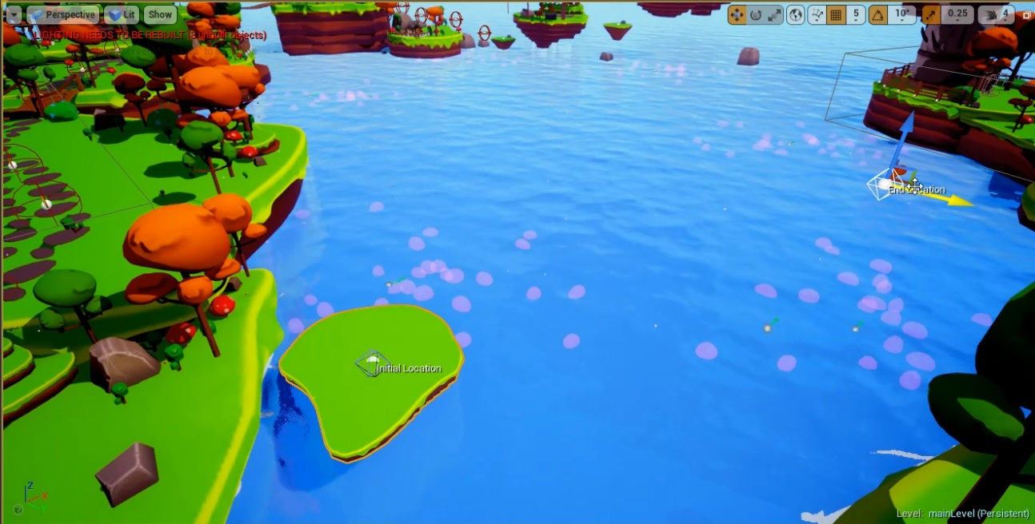

Figure 5- Floating Platform Tool

The Fence tool as shown below in figure 6 allows the designer to quickly place fences around a given area whilst maintaining the same direction as the previously placed fence as to give the fence aligning some continuity. This feature can be overridden easily by manually adjusting the fence to create more sharp shapes such as for creating corner or to square of a section. Using this method also decreased draw calls within the level which means the level loads faster, as the single spline mesh is loaded rather than individual meshes. By utilising spline meshes we are reducing draw calls so that artists and level designers were able to place more assets into the level there by making them more decorated and pleasing for the player to look at and attempt to make the feel like part of the world. Creating tools like the fence tools, really helped the patience of the designers, as placing fencing in perfectly was a chore to do, however becomes more easy whilst also increasing performance of the game.

## 3.1.1 Technical Art In Industry

Figure 6-Fence Tool

An article by (Haynes, 2008) writes about the multitude of roles that a technical artist has (page 2), for instance the tools programmer, of which was briefly just discussed above, goes onto agree with how the tools technical artist develops tools to assist in pipeline such as the artist. It used to be the job of the programmer to make these tools, but he goes onto say how the programmers had trouble communicating with artists, but as the technical artist role has become more apparent in the industry, a person with experience in both art and programming the communication problem seems to dissipate. This is due to their wide skill set and experience with both teams, as they understand both teams perspective and can tailor their tools to what they ask for.

## 3.1.2 How The Technical Art Work Was Approached

The work of technical art was not originally planned but rather was needed by the team as the project progressed. The game needed to become more stable as the game become larger, with more dense levels and more levels altogether. Optimisation techniques were researched and implemented as discussed. The tools idea came out with designers complaining of how it was taking several hours to do a single job which when using the tool could be done in minutes, tools like the path generator and the fence generator allowed the designer to quickly implement their ideas. This made the designers more adamant to level design, which were tested, with the results better levels for the players. This method is similar to the games company Volitions technical art development, as their workflow of implementation of technical art is shown in Figure 7. The tool would be requested by a fellow designer and if the author felt that the tools was achievable to make whilst working on their own work it would then be created. Once created it would be sent to the designer who requested it for feedback if the tool was not satisfactory or not what the designer had in mind a clearer detail of the tool was made as well as

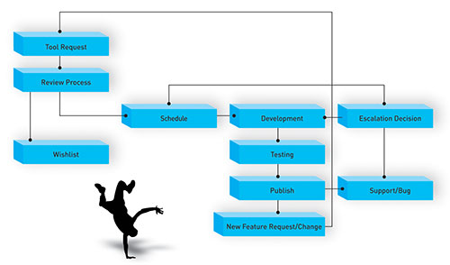

Figure 7-Volition's flowchart for feature requests as well as a change to management plan-2008

## 3.1.3 Problems, solutions and evaluation of this work in comparison to research undertaken

The problem with technical art is that there a numerous amount of aspects to research before anything can be implemented. This can range from optimisation by using the in engine profiler as described in Figure 3 and Figure 4 to developing tools for the designers and researching how to create the tools within the engine whilst also updating and maintaining the tools to keep the demand of the fellow team members of whom were using them for primarily level design unless the tool was designed for another use. The tools themselves needed further testing before being fully integrated, and if the tool was updated it would then need further testing by designers to make sure the new version worked as shown in figure 7.

## 3.2 Testing method

When testing Koala Rama throughout development the team did internal testing. Internal testing is by our own definition is that as we discovered bugs through implementation, we would then report them to the appropriate team member. For instance, if an asset bug was discovered, the artist would fix it, if a compile error was spotted the programmer would fix it. This contradicts how triple-A studios internally test. As described by (Barlog, 2018), Creative Director of Santa Monica Studios in the interview he tells that internal tests were done every two weeks by their dedicated Quality Assurance team. As the team is small, we tested the game ourselves, after time branched out to external testing. External testing was done over multiple sessions and multiple builds. Once the team had a build that was contempt with testing, we then tested that build. The testers were a mix of students and Lecturers. All recorded data from the testers was consensual and all the testers were the appropriate age for testing. If anyone was under the required age their testing data was not recorded. The students testing was either from Bolton College or The University of Bolton. The University students were fellow games course student studying in games design, games art or games programming.

Each tester was to play the tutorial level in order to see if they understood how to play the game and its objective and then the testers play one other level of the game. The level they played depended on which testing station they were at. The team agreed to set a maximum of ten minutes playtime per level and recorded if the tester completed the level or not, if they did their time was recorded. The tester would be asked to report bugs if they encountered any, which we would fix before the next build and repeat the process. If the next builds test reports didn’t contain any of the prior bugs those bugs were then classed as fixed.

The following is the change log to show the fixes and improvements from testing different builds.

After Testing Build 01

* Changed enemy locations
* Changed Rolling to work when moving rather than stationary
* Boomerang now flies to point in the world whenever attempting to throw rather than twirl
* Locked FPS at 60
* Changed Tutorial Dialogue key words to Capitals
* Fixed Quit button not working in game over screen
* Fixed spelling mistakes and grammar.
* Can now Roll to attack enemies
* Fixed bug when trying to throw boomerang when; Running, Rolling and in air

After Testing Build 02

* Fixed bug where in the main level and yellow key quokka will get randomly freed
* Made Keys more visible
* Visual animation for picking up a key
* Animations are now independent from each other
* Displays how many keys you need to enter the portal above the respected portal
* Can no longer talk to the trapped quokka after they are freed
* Adjusted boomerang cross hair to be more accurate
* Controller now works with all UI
* Better overall mixed sound
* Added second path in MichaelLevel02
* Added more coins in MichaelLevel02
* Fixed boomerang sound not playing when coming back to the player
* Added more targets in MichaelLevel02

When designing the game, the team were inclined to create a game with many mechanics all of which needed to be tested as they were implemented into the game. As to make sure that the various mechanics do not interfere with one another and cause bugs, which they did. Attempting to do multiple actions at once, for instance, trying to aim the boomerang whilst rolling would result in the player not being about to throw the boomerang at all. Meaning that at some points where the player needs to hit a target the game was incompletable. That bug was discovered by various external testers, as developers of the game, the testing is internal. As the team developed the game the team played it properly, so this bug never occurred until external testing was done.

# 4. Potential political views on the project

## 4.1 Australian Culture

With the increase in political movement and censorship in recent years as shown by (Mochizuki, 2018), (Grayson, 2019), it is wise to monitor what is being put into the game and to properly research before anything is implemented (Ismail, 2018) of Assassin’s creed(Ubisoft,2017) goes into how much depth their studio goes into research in order to properly respect the culture and history of the real places they base their games. For our project we based our project in a fictious setting however some may feel that it is basing upon the stereotypical Australian culture. As the game Koala Rama contains indigenous animals to Australia such as Koalas, Quokka and Kangaroos. The main character, of whom you control, their main weapon is a boomerang made famous by Australian culture. Residents of Australia may not take kindly to using a form of sterotype in the game and may demand for either a censored version such as by changing the weapon or changing the character models, or simply not permitting it for sale in Australia. As Australia is not new to banning certain games (Walker, 2018) though most of these games are mostly for a mature audience their reasons can stem for violence, sex and drugs. Since in the game you play as a koala collecting golden eucalyptus leaves, the main food source for koala, most people think they get a drug high from these leaves so people could assume that we are prompting drug use, just as they claim the same with Mario, collecting mushrooms (Lee, 2018) .

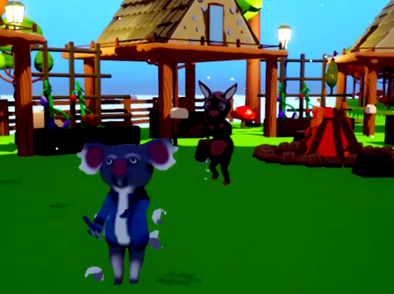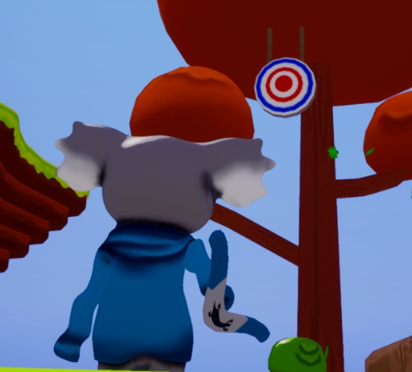

Figure 8- Kuthbert Aiming Boomerang-2019

Figure 9- Kuthbert With Enemy-2019

## 4.2 Fantasy Animal Violence

Since the game contain fantasy violence of animals harming animals it can relate to PETA’s movement against Pokémon (Nintendo,1996) where by PETA suggested that “Pokémon are not ours to use or abuse. They exist for their own reason.” With this statement created a parody game titled Peta’s Pokemon Black and Blue – Gotta free them all. Where you play as a Pokémon exploring the world and killing humans whilst freeing other Pokémon. This was to represent a movement of real-world caged animals of which are captured and made to perform tricks for amusement. Which is very similar to the project where the main objective is to find correctly corresponding keys to free your captured friends (figure 10).

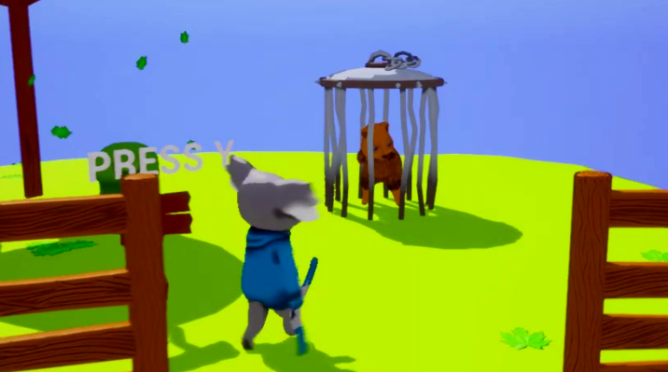

Figure 10- Trapped Quoka-2019

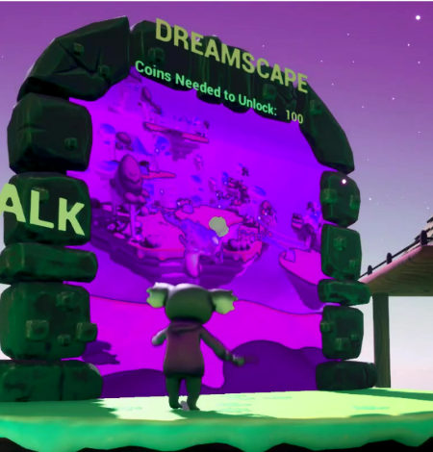

Figure 11- In front of World Portal

## 4.3 Capitalistic propaganda

Throughout playing the game the player in encouraged to collect coins in order to progress to newer levels, however some could view this as a capitalism propaganda or a ‘Far Right’ movement. By enforcing to the player that the game does not progress unless you have a certain amount of credit. An article by (Ashcraft, 2010) goes into say how capitalism is demonstrated in a large amount of games, pushing the agenda that the more currency you have in a game the easy it becomes due to the player being able to afford in game rewards such as power ups or in game items.

## 4.4 Censorship

The main character in the project as do all other characters in the game do not wear any pants, however some wear shirts which can lead to the idea that they in fact exposed. Though the game does not show anything explicit it. Sony told that they are enforcing new censorship guidelines as depicted by (Mochizuki, 2018) of the Wall Street Journal, are “so that creators can offer well-balanced content on the platform” and gaming “does not inhibit the sound growth and development” of young people.

“Sony is concerned the company could become a target of legal and social action,” a US Sony official said to the wall street journal.

An example of a released game of which had to follow Sony’s new guidelines was Devil May Cry 5 (Capcom 2018) in which they use additional lens flares to obscure a female bottom. This censorship is only on the PS4 (Grayson, 2019) as the censorship cannot be found on PC or Xbox One.

With these new censorship rules in place for Sony, if Koala Rama were to be ported to PS4 they may or may not demand a censored copy of the game whereby the characters are forced to wearing clothing, differing from the developer’s original design.

## 5. Reflection

## 5.1 Individual Reflection (Evaluation)

When reflecting on the project it is important to remember how it started, developed and ended. When starting the project, the planning could have been done better, such as the design document and Whitebox. As for when developing the game, the design document was almost forgot about, which lead too making content for the game what was never discussed or talked about. This used up valuable time and resources. Though with this additional content the team did hit all their milestones, meaning we were then able to implement this additional content. Had more time been invested into this documentation the team would have had a clearer understanding of the game and what was too be made. This would have resulted in more efficient working as a clearer vision of the game was available to all the team members.

In the first few weeks of development the team experimented with source control for the first time, some got to grips with the source control faster than others this meant that some people were using it incorrectly, such as committing and pushing certain objects that was conflict with other to create merge errors. These errors occurred mostly with the map file as it is binary and any alteration results in an entirely different file. This cause confusion for a while as some members of the team didn’t understand not understand why they would get certain errors and when attempting to resolve it they would accidently remove the file. This led to a lot of backtracking as some people would accidently delete their work or someone else’s. Never the less after many weeks of practise and using the software the team finally got to grips with the software and were able to utilise it so that development and implementation could run a lot faster.

When in the middle of development, the work load was not shared equally, as some people in the group either did not do the work, or did it too such poor quality that somebody else had to do their work, needless to say the work got done in the end or at least till the next milestone. This created a lot of stress for those team members and effected their other work as more time had to be dedicated to this project.

Towards the end, once the team fixed all the problems with how to make a successful build, it was all polish. This was done by adding sounds, particles and testing the game. Fixing any problems found, I do wish we tested more externally sooner before deadline so that all the bugs found would have had longer to fix and polish. The majority of them were fixed and it was better to know about them and learn how to fix them than to not know of them at all.

## 5.2 Team Reflection

The team worked very well together for the most part, though there were some communication problems which leads back to what was previously stated about creating additional content without consulting anyone. Though this additional content was created after the requirements was done for the milestone, this time could have ben used towards the following milestone as the next few weeks’ worth of work was displayed on the HacknPlan, assigned to the appropriate people. The team was very well formed, if the designers needed something off the artist they would ask if it done and if not, when would it be. To which the artist would give an honest answer, if the requested work was a week away that was fine, as the designers can do other things whilst that it being taken care of or would work with what the artist had just done and implemented. Giving the models in game checks as stated in the technical art section of this document. Working with the programmer was frustrating to start with as there were several delays of the breaks which needed fixing, else production of the game would have to stop for the majority of the team till the issues were fixed, the main problems were with builds or source control. The build problems came with the designers using the unreal engine in visual coding system called blueprint whilst the programmer was doing C++ programming language. Though the blueprint system is based on C++ is was difficult at first to merge the two into a single buildable project.

## 5.3Team Contribution

I do feel that when working on this project some people worked harder than others to deliver a better product, and this came with multiple reasonings. Now though the designers were using blueprints when implementing into the game, the skill level between the designers was massive. So, when a lower blueprint skilled designer made an object I, a higher programming skilled designer would look over it. Most of the time I found myself having to redo their work, simply because it created too many bugs or could have been done a more efficient way. I would try to explain to designers how to do it properly and where they can look to learn but instead never improved upon their skills. Giving me more jobs to do.

With the programmer struggling with the unreal engine, I had to help them too. So, I found myself for a time trying to explain unreal and blueprints and answering questions. When the programmer ran into a problem, they would immediately get me to help, thereby preventing me from doing my work. I felt like I was doing most of their work too at times since it only worked when I was there to fix it. The programmer more so became a QA member at that point constantly playing the game and calling out issues or problems of which I was made to fix since I was the only one with the skill to do it, however this took time out of what I was supposed to be doing and increased my work load. I did however learn a lot and increased my knowledge in programming and team management. This was referred too at the start of the document where I stated the authors role, my role, was more of that of an indie developer working in a lot of aspects of game development because I had to.

## 6. Conclusion

At being at university provided the author with many skills both as personal character development and as to the desired job within the games industry. Through the university course gave an exposure to the insider knowledge and work ethic that is to be expected come when coming to the industry. Something one cannot find in many places. This knowledge and ethic came into great practise for when developing the group project.

Though the developed skills taught in university are very good, a lot of time needs to be spent on research and improving on the skills you already have and acquiring new ones. Doing this in the break between terms has offered me great knowledge and insight on how to communicate with other people in many branches of the industry, being taught as a designer with other designer. With being closed off from the other groups for the majority of the time, it was great to communicate with a wider range of people outside of the acquired skill set to then learn more from.

At the start planning was a problem, as the author comes from a more scientific academic history where you are simply graded on a exam at the end of term and that is your grade. You could revise an hour before, keep the knowledge within your short-term memory and do the exam and do well. Game development is a completely different thing you can tell straight away if someone has spent and hour or 100 hours on a project and this time investment needs planning. This effect came mostly in the second year when first introduced to the artists in a group exercise and now you have to organise around other people. Failing at that made me realise how important it was to prepare for in our major project.

The major project taught the author how to fully utilise the skills gained and use them effectively within a small team environment, coordinating when certain tasks were done and if they were not done what to then do, certain things do in that situation is to talk to the team and discuss when it would be done or if it was actually possible, this would be determined by the person doing it to see if it was within their skill set. Someone else could take up the role or the task could be dismissed or put aside for later implementation if there is extra time.

Audio Notes

Ashraf Ismail (Game Director) of Assassins creed- <http://interactive.libsyn.com/ashraf-ismail-of-assassins-creed>

-Talks about respecting culture and history (32:25

-Prototyping mechanics (44:10-44:40)

Tim Shafer -<http://interactive.libsyn.com/tim-schafer-of-double-fine-productions>

-Brainstorming

-Humour in games

Jenova Chen (thatgamecompany) <http://interactive.libsyn.com/thatgamecompanys-jenova-chen>

-interpreting test data like a doctor (36:50-

(37:30-42:50)

42:50-) “think like an experience doctor, evaluate the data from experience rather than from knee jerk reaction”

Cory Barlog (Creative director) <http://interactive.libsyn.com/cory-barlog>

-Implementing features (47:25-48:15

Testing (46:30-46:50) Playtesting every two weeks

-level design (50:00- 51:30

Ian Dallas -<http://interactive.libsyn.com/ian-dallas>

Mechanics -13:50

# Appendix A – Testing Documents

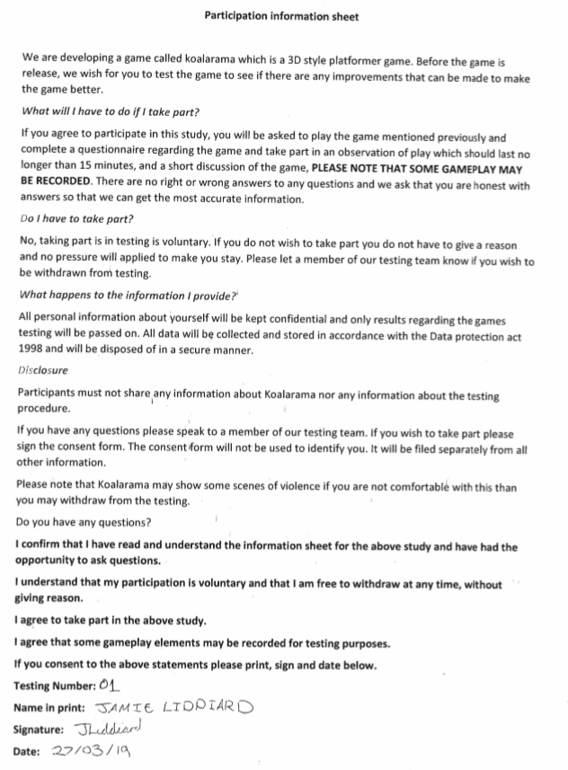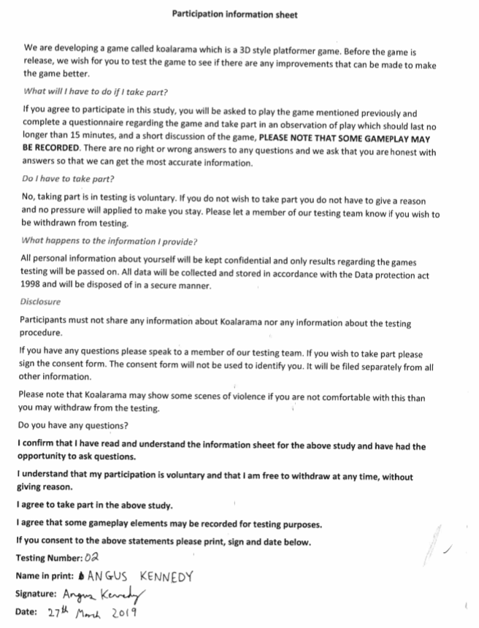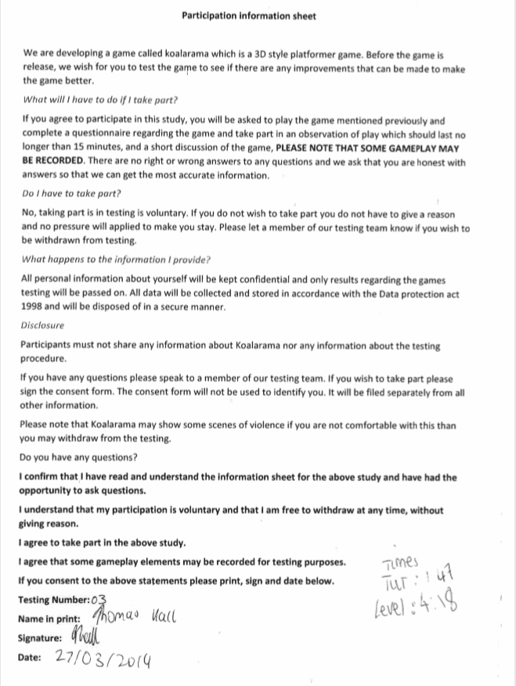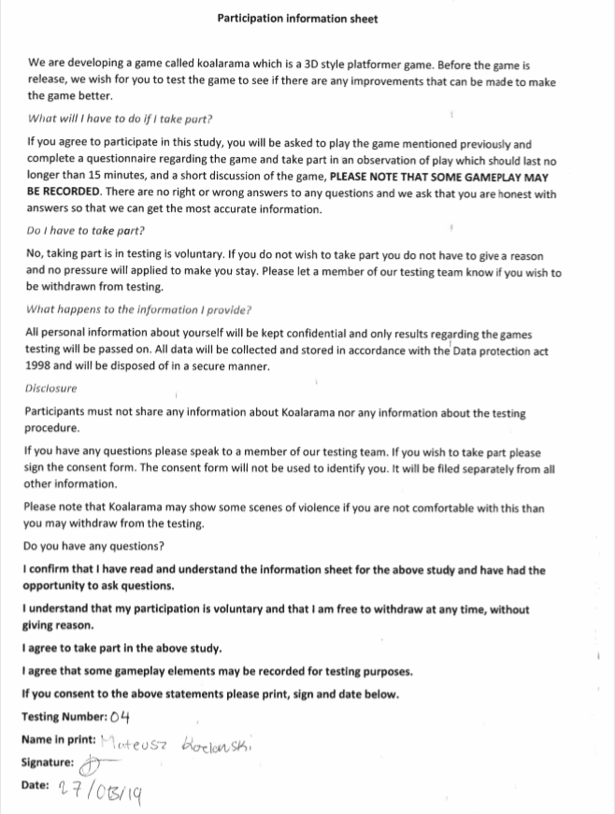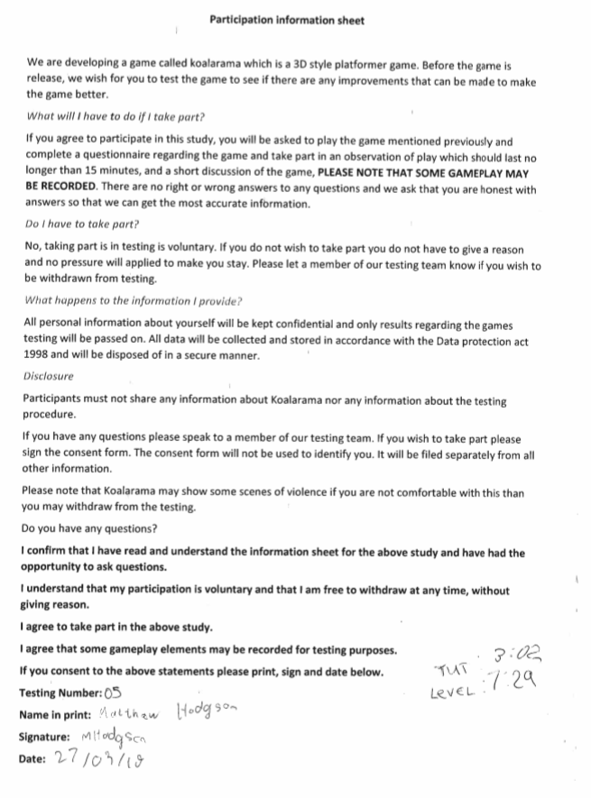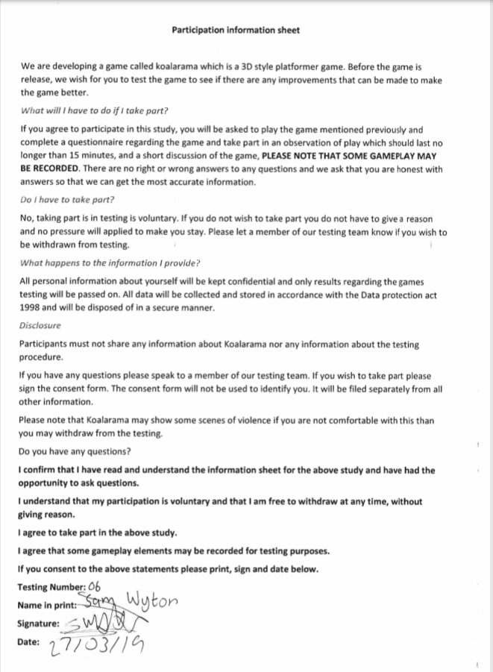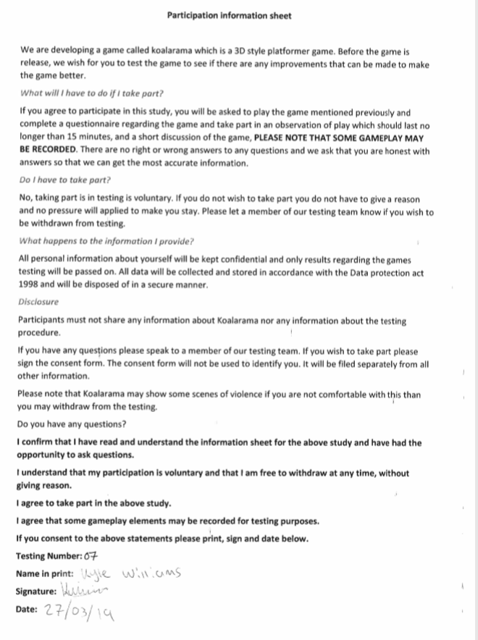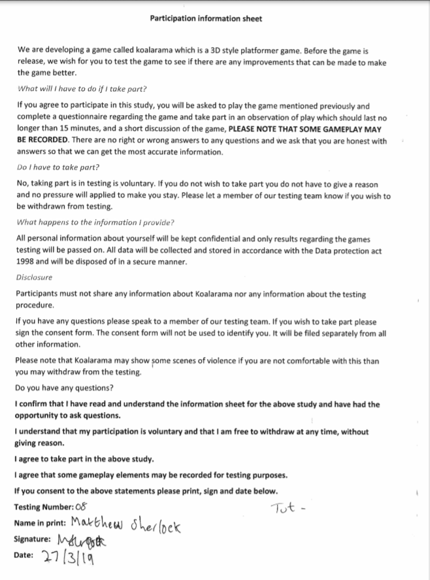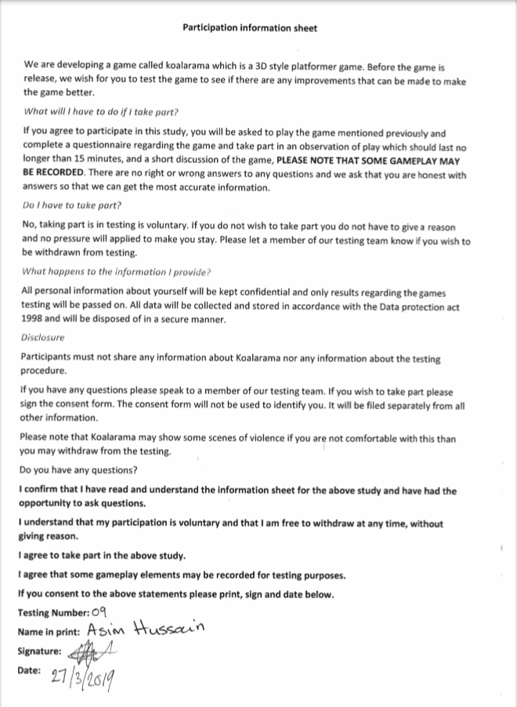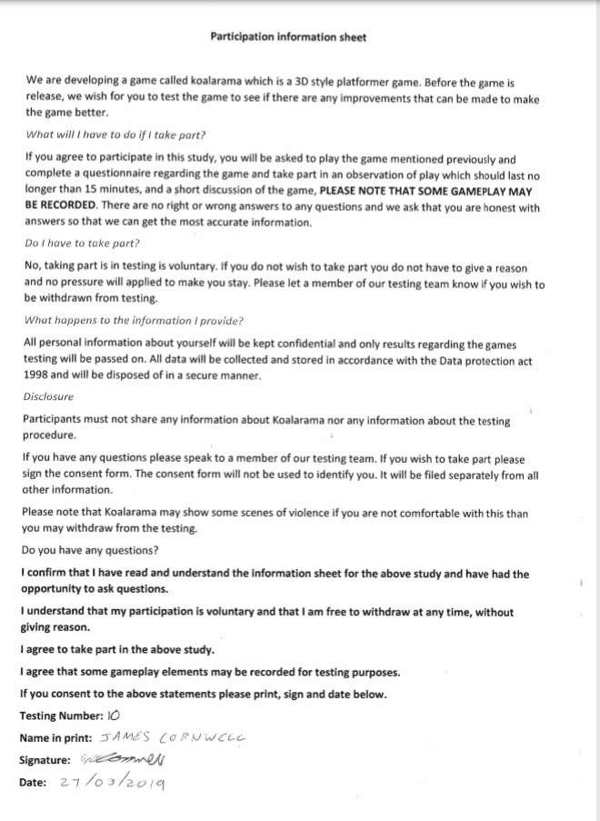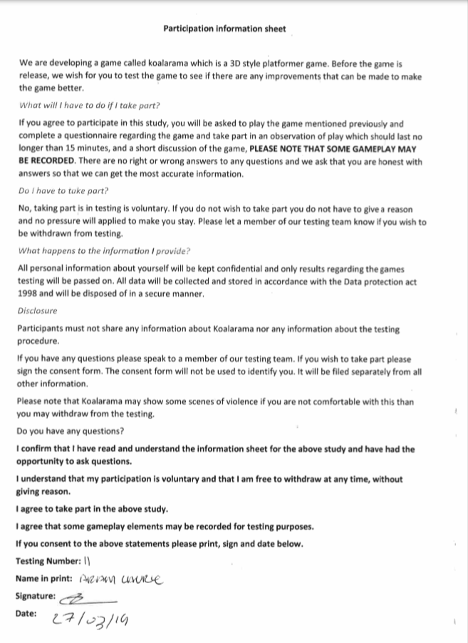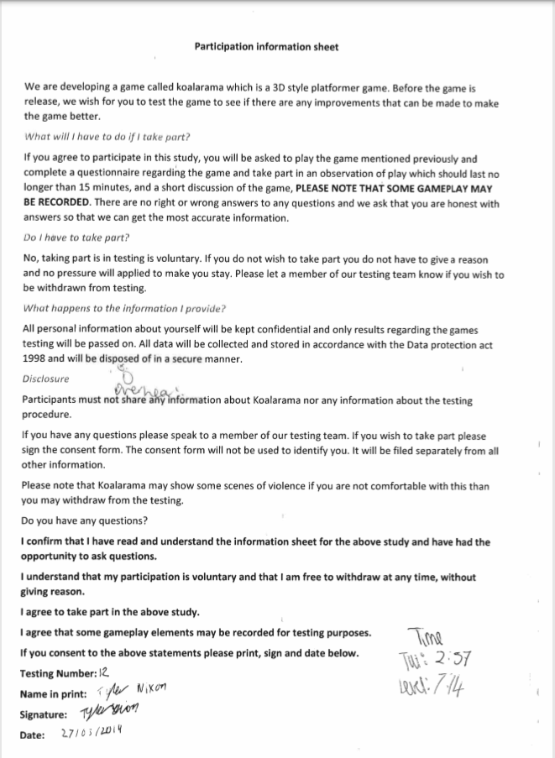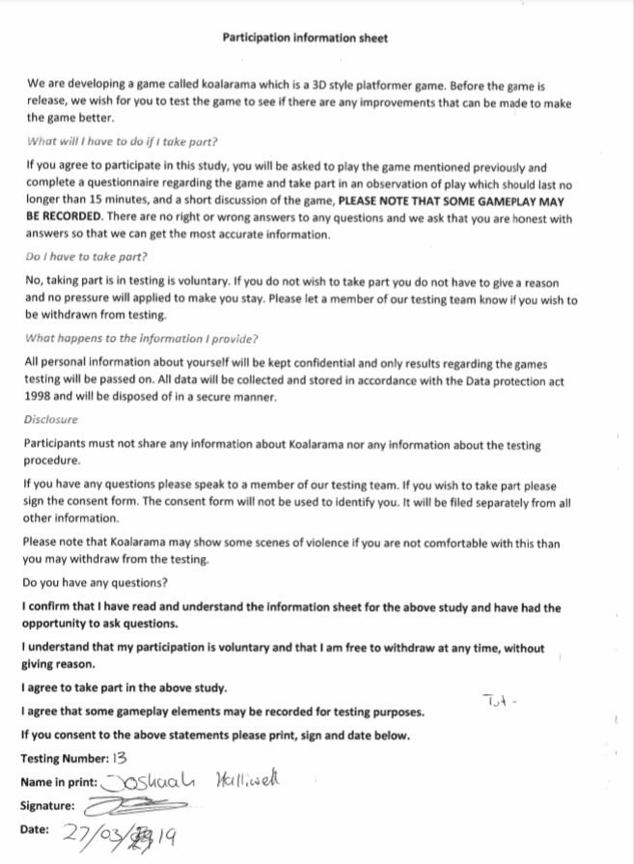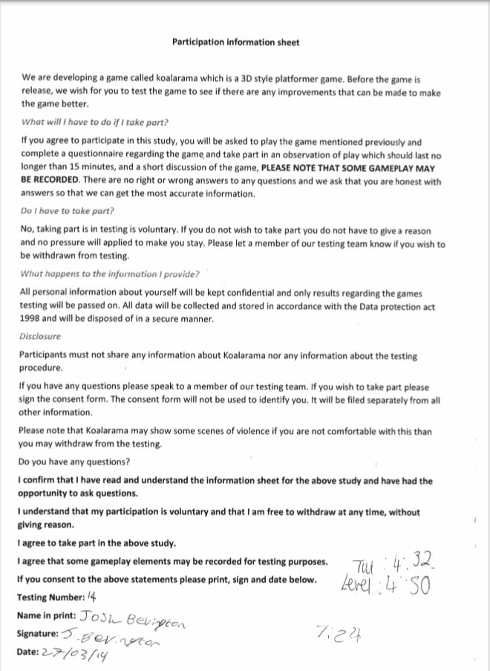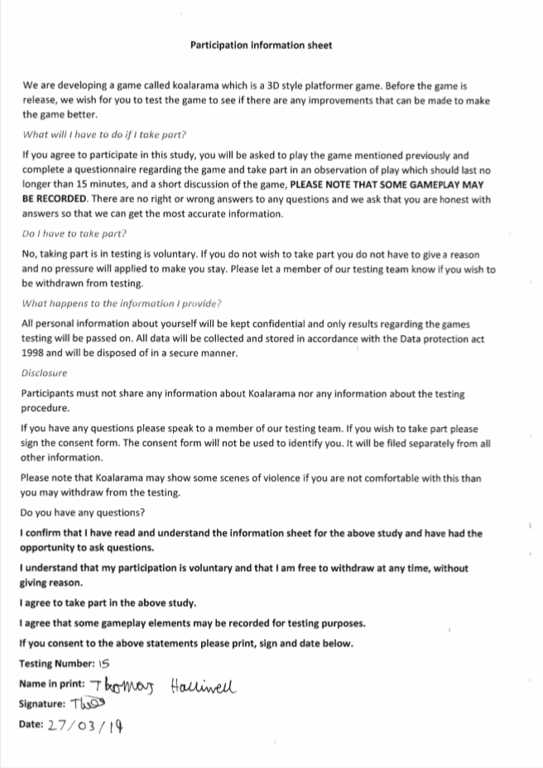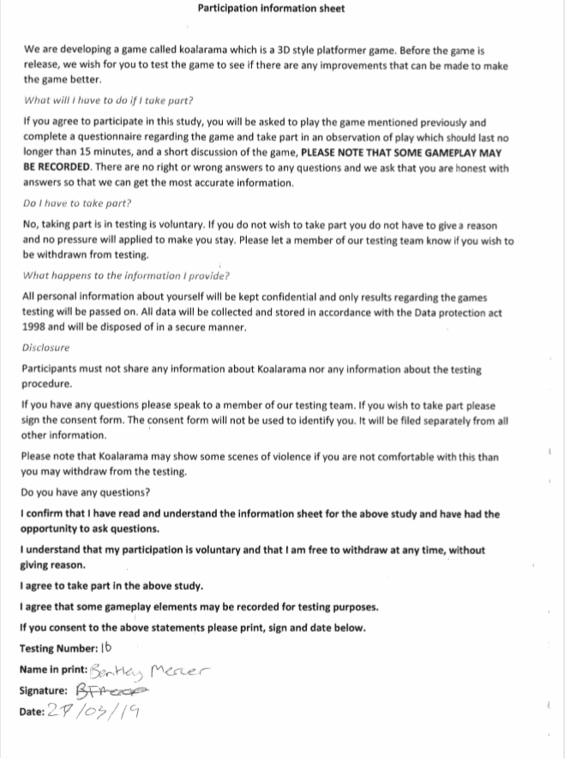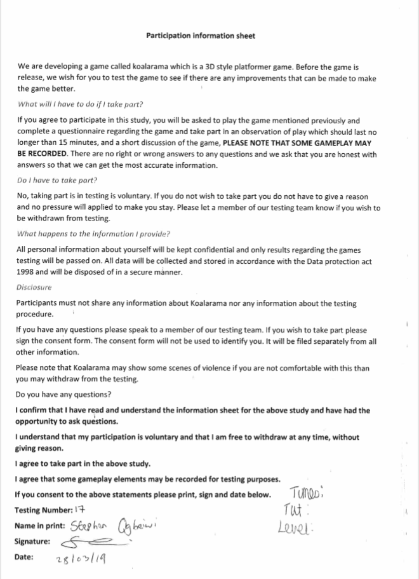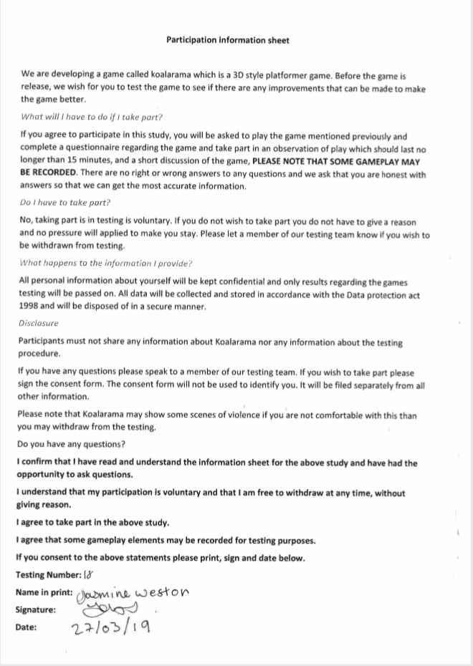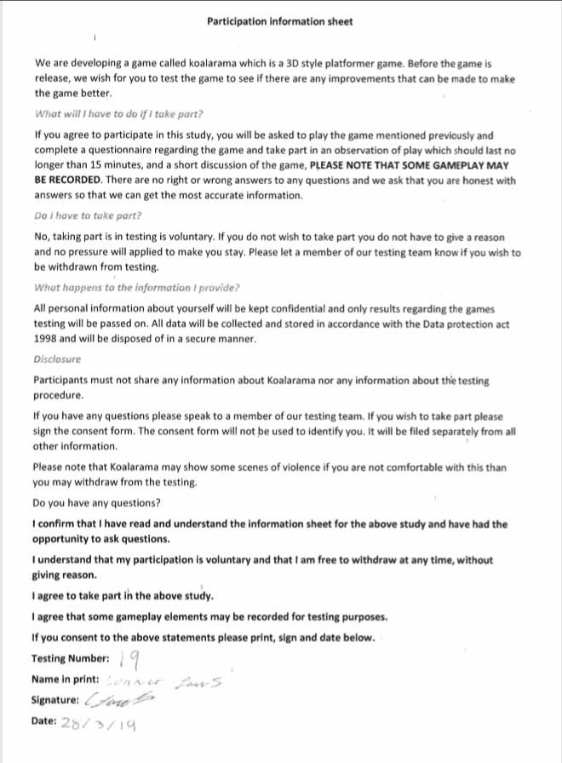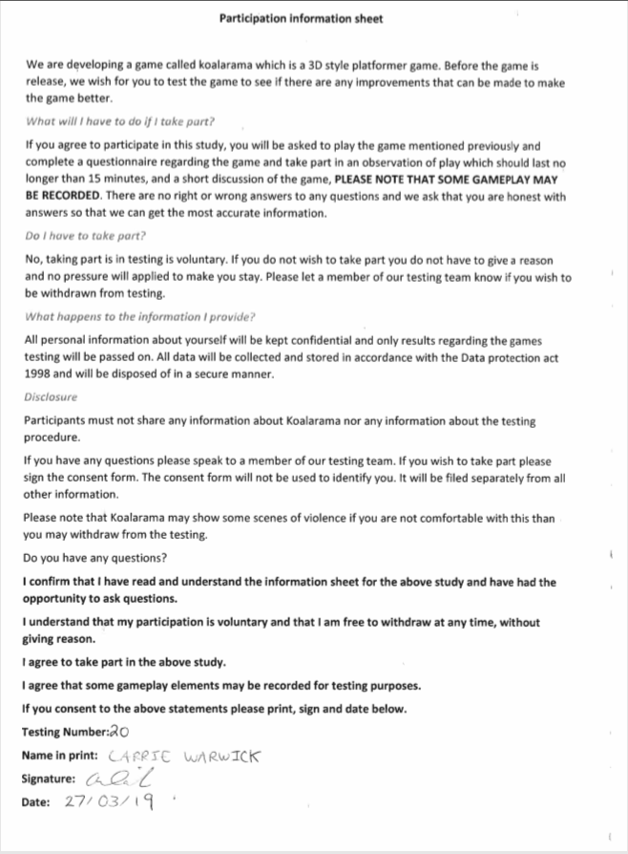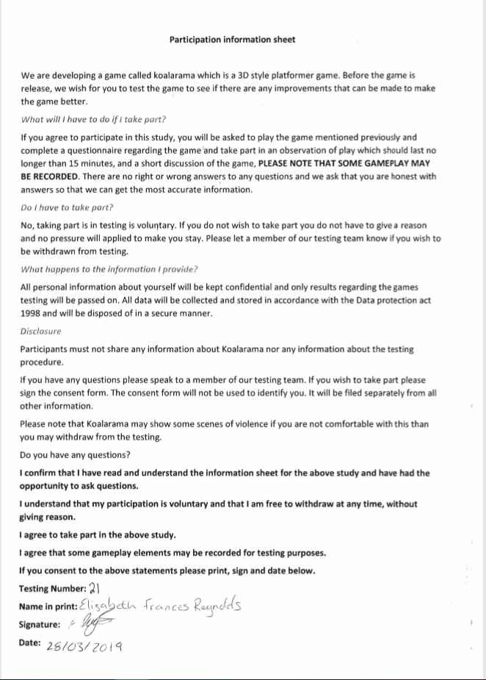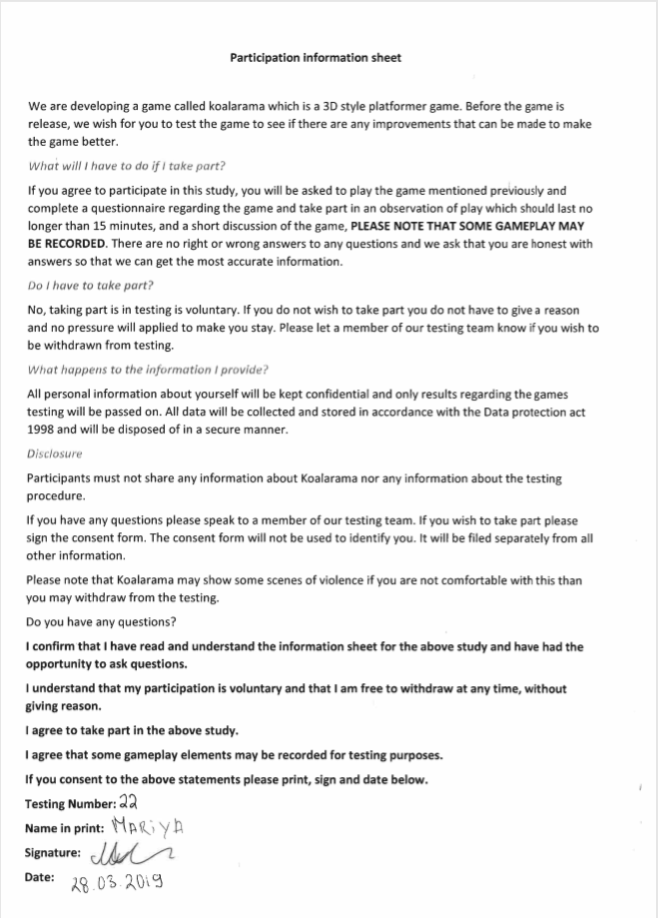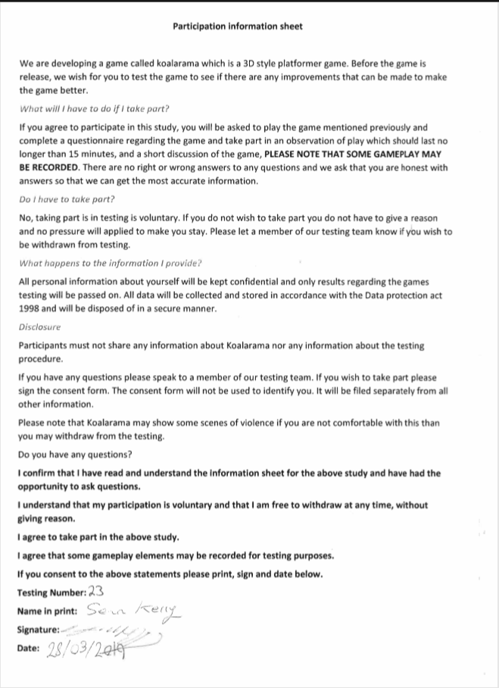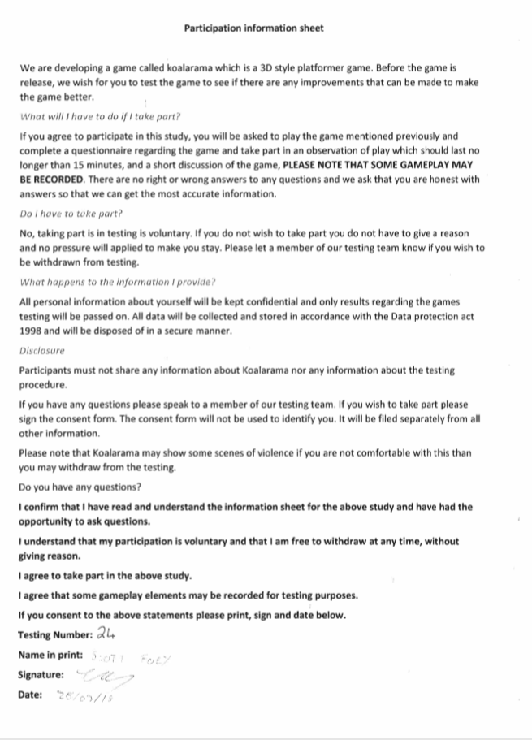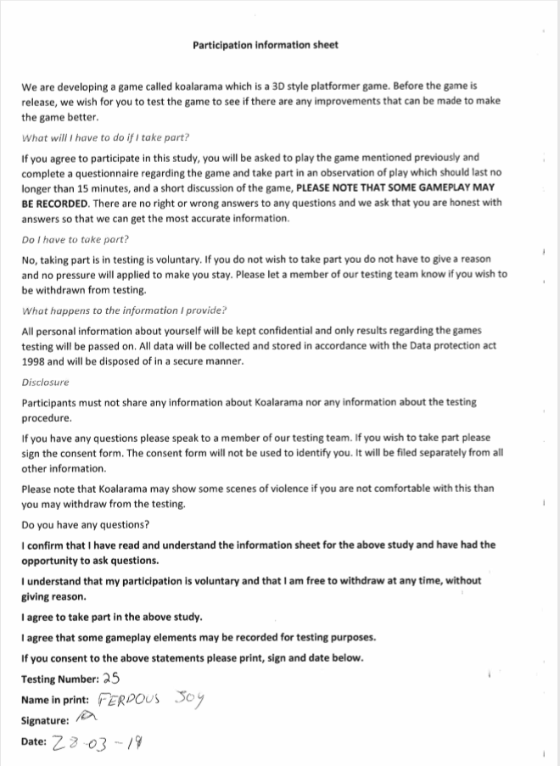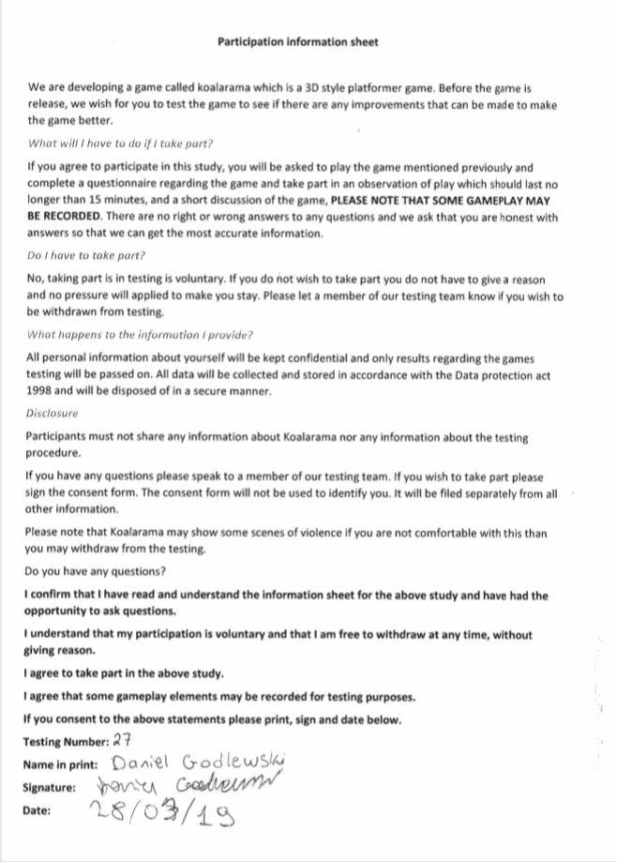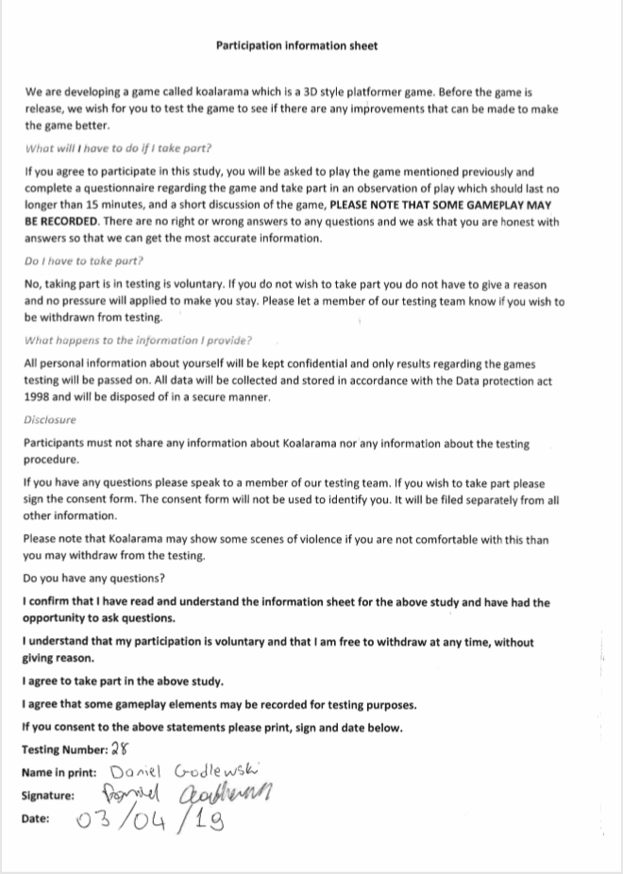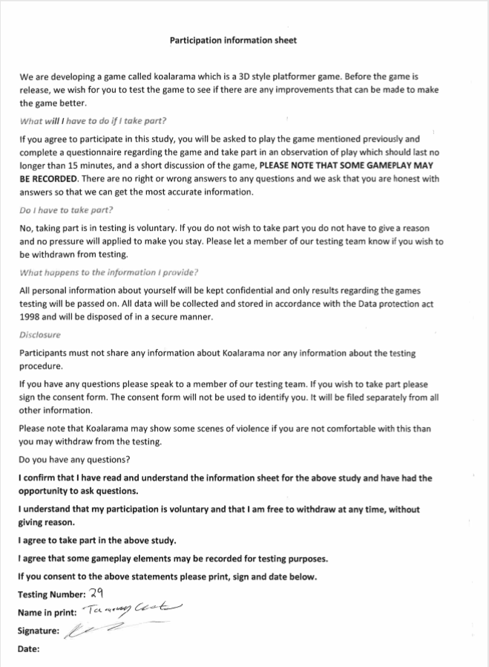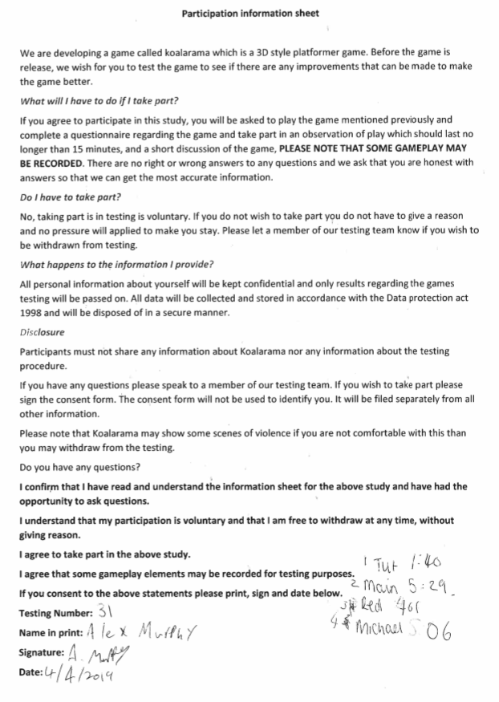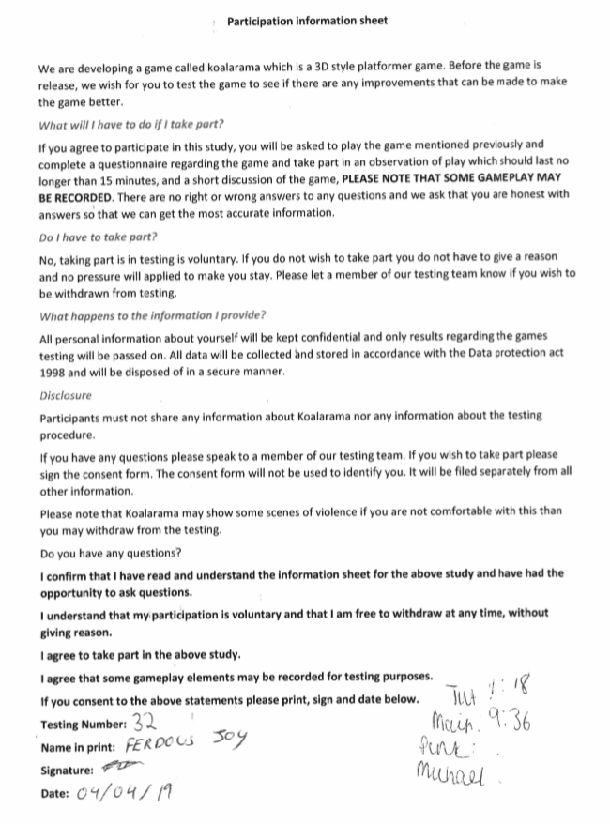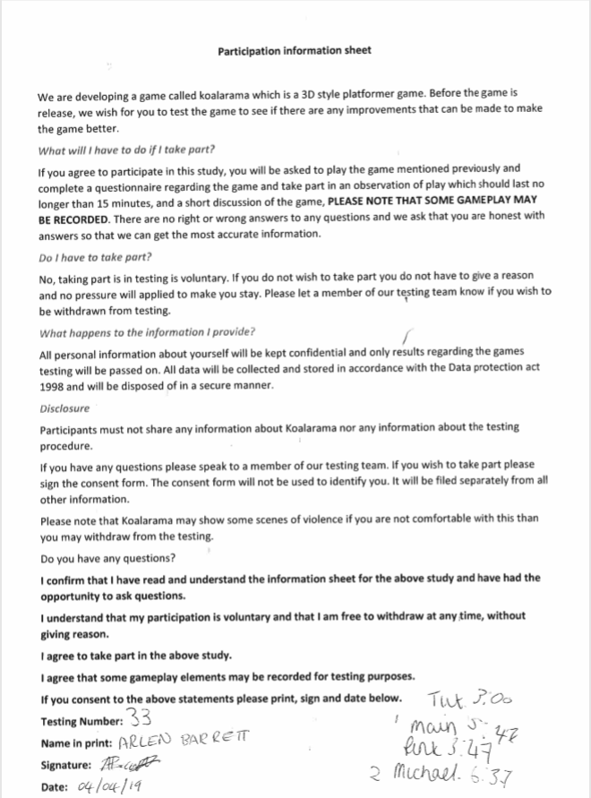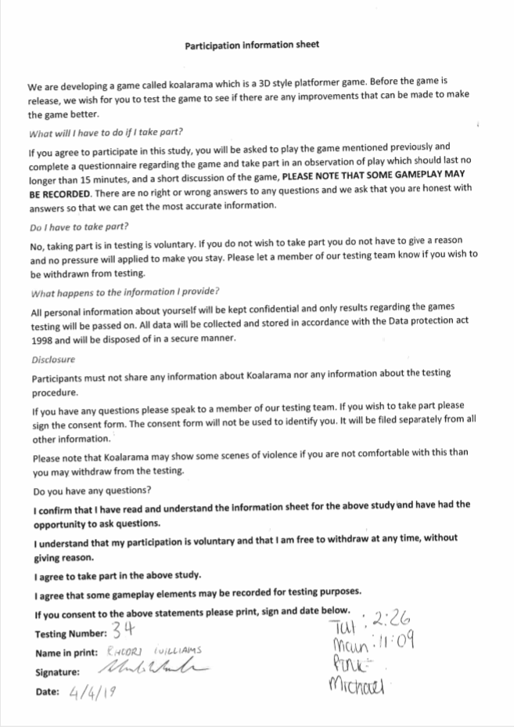

# Appendix B- Literature Review

GAM6001-18 Major Project

Individual Report

Literature Review

Contents

1. Introduction 3

1.1 The Game 3

1.2 Writers’ Role 3

1.3 Workflow 3

1.4 Future planning 4

2.0 Literature Review 4

2.1 What are Game Mechanics? 4

2.2 Mechanics in games 4

2.3 Utilising Mechanics 5

2.4 Boomerang Mechanic 5

2.5 Player Mechanic Progression 6

2.6 Mechanics in Level Design 6

2.7 Testing Mechanics 6

3.0 Conclusion 7

4.0 References 8

Abstract

This Critical Report is to reflect on how game mechanics in games can change the course of development once implemented. This will show how mechanics are used in games, both good and bad and how these decisions on implementing these mechanics caused the design of the game to change later in development. This change can be from level design to overall gameplay.

1. Introduction

1.1 The Game

The name of the current project is ‘Koala Rama’. It is a 3D platformer ‘Collectathon’. A ‘Collectathon’ is a slang term used within the gaming community to identify a game in which the player must collect a threshold of items to progress through the game. In order to progress through the game, the player (who plays as a bi-pedal Koala) must find keys to free their fellow Koala friends, to get these keys they must explore the world around them. By using a variety of player mechanics to access different areas of the level. These mechanics are unlocked by collecting the second type of collectable, the more abundant collectable, Eucalyptus leaves. Once a threshold is met the player unlocks an ability so that they can access another part of the level. An example would be after fifty leaves were collected the ability of wall jump would then be unlocked. So then the player can now jump between parallel walls to go to an area they have not access before. Once in the new area the player can go on to collect that areas key and free that areas friend and go on to collect more Leaves. The additional leaves in that area allow the player to unlock a new ability, to go to a new area. This is repeated till the player has visited all the areas in the game and has freed all the friends.

1.2 Writers’ Role

The writers’ job in this group project is to firstly plan out the game with other designers, create a design document of the game. The design document contains details of what the game is and what you are able to do with in the game. What you are able to do in the game are the mechanics of the game. So, one of the main tasks the writer was to do is create the prototypes of the player mechanics which will then be optimised later by the group programmer. The second job is to create, import and utilise animations for the player character. The animations are being sourced from (Mixamo.com, 2018). Since there are going to be many mechanics, these need to have some form of visual feedback as talked about by (Cook D, 2006) who goes on to say, “Game Mechanics are rule based systems / simulations that facilitate and encourage a user to explore and learn the properties of their possibility space through the use of feedback mechanisms”. Though this is not a clear definition of game mechanics as a whole, it is compared later with other definitions later in the report. A basic player model was created and used to create the animation states that would then be used and tested, so that later when the main model is done the animation states can simply be retargeted to the newer model whilst maintaining the same data from tests.

1.3 Workflow

For our workflow the team have created weekly tasks which is incorporated in our (HacknPlan, 2018). The team have organised between themselves the tasks, and what needed doing first and started those tasks. The writer firstly began with implementing new walking animations as well as creating a boomerang mechanic similar to (The Legend of Zelda: Breath of the Wild,2017) where at any moment if the player has the boomerang equipped, they can aim, throw it and it will curve back to the player for them to catch and rethrow it, if they want too. The throwing animation was done, as well as most of the boomerang mechanics. The only problem is, when a boomerang is thrown it rotates and for it to curve, I need to get the right vector of the halfway point of the distance it travels and since it rotates, the right vector changes constantly, so it comes back in a sort of spiral to the player. This problem was documented for later fix since it is not game breaking at that point in development. This workflow of testing is how we plan to test our game internally throughout the development.

1.4 Future planning

The problems to be expected to encounter in the coming weeks, is that more mechanics need implementing, while the Whitebox is already complete. With the implementation of the newer mechanics, they need to be tested and see how well they work and redesign the Whitebox accordingly. The current fear is that so many mechanics are implemented that the level loses its sense of an open area and is just littered with obstacles which can only be used later on. Making the player feel like they can’t do anything as soon as they begin to play the game. A Game that is similar to this is (Yooka-Laylee,2017), as the player is thrown into a world which at first are unable to do much, while going pass parts of the map or seeing activities that are locked due to their low progression. But as the player acquires more abilities that adds variety to gameplay allowing for replay-ability.

2.0 Literature Review

2.1 What are Game Mechanics?

Game mechanics as described by game designer (Rouse, 2005) are “The guts of a design document” as they “Describe what the player can do in the game world, how they do it, and how that leads to a compelling game experience” (p.310). Which I believe to be an accurate statement as before development has begun, the main designers and team must coordinate their abilities into the design document and strategize the premise of the game, which is the beginnings of the game and its development.

However, a more improved upon definition of game mechanics, some might say comes from (Cook D, 2006) who goes on to say, “Game Mechanics are rule based systems / simulations that facilitate and encourage a user to explore and learn the properties of their possibility space through the use of feedback mechanisms”. The key point in that quote is the feedback mechanisms, the player must have some form of feedback to what they are doing in game, this can be shown by ‘UI’ user-Interface or primarily, Animations.

With these sources, a conclusion could be met to say that the mechanics of a game is something the player is able to do in game which was planned before hand in the design document whilst in Realtime gameplay giving feedback to the player as to the effects of the mechanic. This philosophy is something that the team intends to carry on through the development of the game and its implementation of its mechanics.

2.2 Mechanics in games

The amount of player mechanics facilitated to the player, needs further planning and testing, since there is a limit to how much you can implement before it gets too overwhelming for the player and too complicated for the player that they get lost in the control scheme and in turn gives them a reason to stop playing. A video from (WhatCulture Gaming, 2018) created a video detailing well praised games in which contained a mechanic that players did not find enjoyable, through collective reviews of the games. An example of one of the games described with an overwhelming mechanic is the Batman Arkham series: (Arkham Knight, 2015), the player is forced through sections of the game when you must control a tank and destroy other tanks, the presenter of the video, Will Earl, says the reason players hate it, is due to how frequent the missions are and that the missions are duplicates of each other. Resulting in an expression of boredom through repetitiveness. Another example is (Sonic Adventure 2,2001), a game journalist who goes by (ProJared, 2015) who describes that, “the only tolerable parts of the game is when you play as Sonic” as through the game you are forced to play as separate characters. The majority of complaints about the game, came from too much mechanic variety such as; you would be moving at high speeds as is the normal sonic gameplay, however when the next level of the game came, you were now suddenly collecting all the parts of the master emerald, and some levels consisted of the player playing as a robot shooting almost as if a third person shooter, which stems very far from the original sonic gameplay. If you didn’t enjoy a certain type of level it became a pain to do them since they appeared multiple times throughout the game.

2.3 Utilising Mechanics

As a problem has been recognised in the previous section about implementing mechanics into the game, the team aim to make the collectable mechanics aspect of the game to not feel like a chore, so though the leaves are abundant the team won’t make it so the level is littered and will place them more so to entice places to go to that particular area. Where there may be a hidden area or a path they didn’t see before. Similar to (Super Mario Odyssey, 2017) with the placement of coins near the edge of level, where a lower edge can be seen and jumped too. Or by seeing coins through a waterfall showing the player they are able to go through or behind the waterfall into an area they might have had trouble finding. This form of design is called ‘Clarity’ by (GDC, 2017) who describes the method of “Naturally drawing the eye places”, which can be used as a form of bread crumbing. To encourage the player to explore areas they tend to naturally look at due to this ‘clarity’ method, by removing objects around what you want the player to look at so they are naturally fixated on it. The team want to fully utilize this method in the level design as to show players paths to newer areas and so fully utilise the mechanics of the game.

2.4 Boomerang Mechanic

At the start of the game development the team knew, for the main character, to incorporate a weapon. A unique weapon with its own mechanic which can be used in more ways than one, the team thought of the boomerang, a weapon you could throw and come back to the player. Almost like the Leviathan Axe from (God of War,2018), however the boomerang would curve and would automatically come back to the player after a certain distance. The boomerang could be used to solve puzzles like knocking a key out of a tree or cutting a rope in the distance. The boomerang could also be used to stun enemies similar to how the boomerang is used in (The legend of Zelda Phantom Hourglass, 2007), the boomerang is not a lethal weapon as is more of a tool used to collect far away items and stun enemies within throwing distance of the boomerang. As the player has this mechanic from the start it is heavily incorporated as to how we design the level, creating far enough distances so that they boomerang is able to travel. Creating wide open spaces with enemies as so the player is able to fully utilise it.

2.5 Player Mechanic Progression

The team then thought of how to incorporate how exactly you gain these abilities / mechanics, through gaining progress or through a vendor. Much like how you unlocked abilities in (Yooka-Laylee,2017) as the player would acquire a certain number of items, go to a vendor and choose which ability to unlock using the items they had collected. Though the team will not be utilising the vendor in our game the item threshold is kept. Another inspiration is (Spyro 2- Ripto’s Rage,1999) the player would progress through the levels and notice ladders which were not usable till much later in the game once the player had collected enough gems and given them to the vendor ‘Money Bags’, the player did not have a choice in which ability they unlocked and the order in which you unlocked them was maintained. So that later when you unlocked an ability you can go back to previous levels and unlock new content which was previously inaccessible to the player. By doing this the developer can in a way guide the player as to what they can now do and where they can now explore, it also gives a form of rediscovery when replaying older levels with newer abilities something the writer is keen to recapture in the game.

2.6 Mechanics in Level Design

In an interview between GamesRadar.com and Game Director Cory Barlog, famous for his work in the God of War series, he talks about in the newest instalment in the series (gamesradar.com, 2018), that as the development of the game was taking place and depending on what already was done and tested in game. In terms of prototypes in mechanics or level design, they adjusted things accordingly. So, if the level was not specified to a particular mechanic in a particular way, they altered the level depending on what mechanic was then being implemented. Showing that they did not stick to original white boxes of levels and rather evolved the world around the player and what they are able to do in the world and test. Which relates back to (Rouse, 2005) definition of game mechanics “Describe what the player can do in the game world, how they do it, and how that leads to a compelling game experience” (p.310). It shows that the mechanics have an effect on the game world rather than the game world effecting the mechanics of the game.

As with the game the team are creating, Koala Rama. The idea of development is to approach the same way as Cory Barlog did with (God of War, 2018), and to follow the ideology of (Rouse, 2005). That once we have implemented a mechanic into the game, to test it thoroughly in the current version of the Whitebox, and if alterations are needed to be made to fully accustom the new mechanic then they will be added.

2.7 Testing Mechanics

Once a mechanic has been implemented into the game, the team needs to see what works and what needs changing, be it the mechanic or the level itself. If the mechanic is not working as intended, or the tester feels like a certain aspect of the mechanic could be improved upon, notes will be made and incorporated later if needed. An example of what is to be expected to receive as feedback for the Boomerang mechanic, which was mentioned previously, is that it doesn’t return to the player properly. Also the throwing animation for the boomerang needs changes because it does not look organic and more so robotic. Once this feedback is received and the issue is clearly how the boomerang operates and not the level. The boomerang mechanic will change rather than the level. However, if feedback from a tester says that the boomerang is unable to hit a certain target due to an obstruction in the level, then changes will be made to the level rather than to the mechanic. This continuous feedback technique will help fine tune every aspect of the game, making for a more enjoyable experience for those who play the final build.

3.0 Conclusion

In the introduction the premise of the game was addressed, as well as its accordance with the mechanics it will possess, and how the mechanics relate to previously released games.

During the report, aims were split to show an understanding of, what mechanics in games are, how they are used and how they affect development.

To show what games are, quotes were used from articles written by developers and what they mean to me and my own opinion of what mechanics are based upon their original writings and how I will apply the philosophy during the development of the game.

Once a definition of game mechanics had been established, I went on to say of how they are used in games and how people respond to the game and its mechanics. The games chosen can be praised but due to certain mechanical aspects of them lead to consumers disliking the product. These flaws, of which were brought about due to poor mechanic design and level design, are looked into further later once I talked about how games incorporate the mechanic progression into their game and how I intend to implement the same form of system by progressing after a threshold of items and a once the player has made it to a certain point in the game, combining elements from a variety of games which were also discussed.

A comparison has been shown of how games have properly used game mechanics and how some have not and where those problems lie. These problems were then related back to the project that is being developed. How the game develops around the development of prototyped mechanics has also been addressed in the sense of the game adapts to the laws that were given to it as game mechanics.

4.0 Literature Review References

Cook, D. (2006). What are game mechanics?. [Blog] Lost Garden. Available at: http://www.lostgarden.com/2006/10/what-are-game-mechanics.html [Accessed 4 Nov. 2018].

EPIC GAMES. (1998) Unreal Engine. [Software] Unreal Engine 4.20.3 Cary, NC: EPIC GAMES.

gamesradar.com (2018). "A lot of Kratos' journey is mirroring my own": watch our interview with God of War's Cory Barlog. [video] Available at: https://www.gamesradar.com/uk/a-lot-of-kratos-journey-is-mirroring-my-own-watch-our-interview-with-god-of-wars-cory-barlog/ [Accessed 17 Nov. 2018]. 3:45 – 4:25

GDC (2017). Low Poly Modeling: Style Through Economy. [video] Available at: https://www.gdcvault.com/play/1024405/Low-Poly-Modeling-Style-Through?fbclid=IwAR3qbTeOgNm1D0kyHe1g2UMo3zuFIgINisLWS5qxe3T8C-Y8WQIzlxFTmQU [Accessed 27 Nov. 2018].

HacknPlan. (2018). Project management for game development - HacknPlan. [online] Available at: https://hacknplan.com/ [Accessed 18 Sep. 2018]

Insomniac Games (1999). Spyro 2: Ripto’s Rage [Video Game], Burbank, CA: Sony Interactive Entertainment.

Mixamo.com. (2018). Mixamo. [online] Available at: https://www.mixamo.com/ [Accessed 18 Sept. 2018].

Nintendo (2007) The Legend of Zelda: Phantom Hourglass [Video Game], Kyoto, Japan: Nintendo.

Nintendo Entertainment Planning & Development (2017). Super Mario Odyssey [Video Game], Kyoto, Japan: Nintendo.

Nintendo Entertainment Planning & Development (2017). The Legend of Zelda: Breath of the Wild [Video Game], Kyoto, Japan: Nintendo.

Playtonic Games (2017). Yooka-Laylee [Video Game], Staffordshire, England: Team17 Digital Limited.

ProJared (2015). Sonic Adventure 2 - ProJared. [video] Available at: https://www.youtube.com/watch?v=JgG--74XExY [Accessed 2 Nov. 2018].

Rocksteady Studios (2015). Batman: Arkham Knight [Video Game], London, England: Warner Bros. Interactive Entertainment.

Rouse, R. (2005). Game Design: Theory and Practice. 2nd ed. [ebook] Plano: Wordware

Publishing, Inc, p.310. Available at: https://gamifique.files.wordpress.com/2011/11/5-game-design-theory-and-practice.pdf [Accessed 20 Nov. 2018].

SIE Santa Monica Studio (2018). God of War [Video Game],Santa Monica, CA: Sony Interactive Entertainment.

Sonic Team (2001). Sonic Adventure 2 [Video Game], Tokyo, Japan: Sega.

WhatCulture Gaming (2018). 6 Amazing Games Almost Destroyed By Terrible Mechanics. [video] Available at: https://www.youtube.com/watch?v=cWUiknGt_PA&index=42&list=PLC4v6lyVR1vXWQ8tH6gs-_b1VcAZiyeQK [Accessed 27 Nov. 2018].

# 7. Bibliography

Ashcraft, B. (2010). How Video Games Taught Me Everthing About Capitalism. *Kotaku*, 1.

Barlog, C. (2018, May 25). God of War's Cory Barlog. (T. Price, Interviewer)

EPIC GAMES. (1998) *Unreal Engine.* [Software] Unreal Engine 4.20.3 Cary, NC: EPIC GAMES.

Freeman, W. (2015). Mike Bithell: ‘The highs and lows of creative freedom are very addictive’. *TheGuardian*, 1.

Freeman, W. (2015, Oct 13). Mike bithell: 'the highs and lows of creative freedom are very addictive'. The Observer Retrieved from <https://search-proquest-com.ezproxy.bolton.ac.uk/docview/1721796971?accountid=9653>

Full Sail University. (2018). *Technical artist*. Retrieved from GetInMedia.com: http://getinmedia.com/careers/technical-artist

Grayson, N. (2019). Devil May Cry 5 Slightly Censored, But Only On PS4. *Kotaku*, 1.

Hawkins, BM 2005, Real-Time Cinematography for Games, Charles River Media, Hingham. Available from: ProQuest Ebook Central. [1 April 2019].

Haynes, J. (2008). The Code/Art Divide: How Technical Artists Bridge The Gap. *Gamasutra*, 1-3.

Ismail, A. (2018, August 14). Ashraf Ismail of Assassin's Creed. (T. Price, Interviewer)

Johansson, M. P. (2015, 9 20). *Composition Over Inheritence*. Retrieved from Medium.com: https://medium.com/humans-create-software/composition-over-inheritance-cb6f88070205

Lee, D. (2018). Top video games depict unrealistic drugs use says study. *BBC NEWS*, 1.

Minkkinen, T. (2016). *Basics of Platform Games.* kajaanin: kajaani university of applied sciences.

Mochizuki, T. (2018). Sony Cracks Down on Sexually Explicit Content in Games. *The Wall Street Journal*, 1.

Nintendo Entertainment Planning & Development.(2017) *Super Mario Odyssey*.[Download] Nintendo Switch. Kyoto, Japan: Nintendo

Russka, E. (2015). *QUALITY ASSURANCE TESTING IN VIDEO GAMES.* Tampere: Tampere University of Applied Sciences.

Schell, J. (2008). *The Art of Game Design: A book of lenses.* Boston: CRC Press.

Sokanu. (2019, 04 15). *What does a technical artist do?* Retrieved from CareerExplorer: https://www.careerexplorer.com/careers/technical-artist/

Ubisoft. (2016, 04 14). *Tehnical Art At Ubisoft.* Retrieved from Youtube: https://www.youtube.com/watch?v=mJCkPqpn_Zk

Walker, A. (2018). A Look Back At Some Of The Games Australia Has Banned. *Kotaku*, 1.

Toys For Bob. (2018) *Spyro Reignited Trilogy*. [Disc] PlayStation 4. Santa Monica, CA: Activision

Unique New Academic Degree in Visual & Game Programming for Southern California; Curriculum to Train 'Technical Artists' for Animation and Video Game Industries 2006, , PR Newswire Association LLC, New York

Nintendo. (1996) *Pokémon Red and Blue*. [Disc] Game Boy. Kyoto, Japan: Nintendo

Ubisoft Montreal. (2017) *Assassin’s Creed: Origins*. [Disc] PlayStation 4. Montreuil, France: Ubisoft

Capcom.(2018)*Devil May Cry 5*. [Disc] PlayStation 4. Osaka, Japan: Capcom